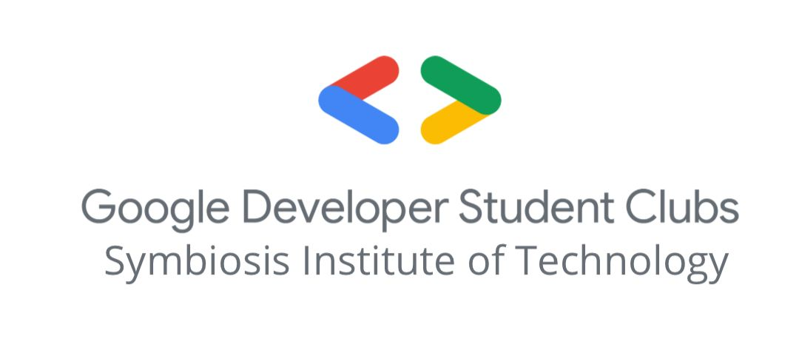

**Google Solution Challenge**

**Date:** 3rd December,2023 -22nd February, 2024

**Location:** Online, GDSC Challenge Web Platform

**Conducted by:** GDSC India, Managed in SIT by Aaradhya Badal

**Introduction:** The mission of the Solution Challenge is to solve one or more of the United Nations' 17 Sustainable Development Goals using Google technology.

Since 2020, Google Developer Student Clubs (GDSC) members from around the world come together to create innovative solutions to tackle some of the world's most pressing challenges.

**Event Highlights:**

Many Events across the span of three months were conducted. Everything from building and shaping projects to spreading awareness about the Solution Challenge.

**Awareness Campaigns:** The first month of the campaign was all about spreading awareness and inspiring people, by gathering and discussing with all the leaders and formulating a roadmap.

**Technology Wise Groups:** Leads of respective departments took charge and made subgroups to guide people, various mentors were also decided.

**Shortlisting Participants and Mentorship:** All the subgroups conducted shortlisting programming and discussing ideas and strategies for the challenge. The objective was to find committed students and leverage their ideas with the help of experts.

**Doubt Clearing Session:** A doubt-clearing session and explanatory session about the general GDSC solution challenge was conducted. A final initiative to spread awareness.

**Google Solution Challenge Boot Camp:** India Regional Bootcamps are in-person help sessions designed to provide teams with guidance from domain experts. These sessions are being organized offline in 10 cities across India. The exact locations in the cities, as well as the dates and times, will soon be disclosed. Participants are advised to keep an eye on their inbox to ensure they do not miss out on this valuable opportunity.

Google Solution Boot Camp was a huge success, all the people who registered were selected for this rare opportunity. Participants were invited and delivered. We had a total of 5 teams selected.

**AI and SDGs:** To Check the progress of the participants using AI technologies in their projects. Insights from Boot Camp were also shared. Projects were given advice and pushed for further development. Conducted by Dhvani Parekh, Aarohi Panicker, Aaradhya Badal, and Riya Shukla.

* Hevardhan’s Team presented his progress on the “Learn Hub” project and their experience in GDSC Boot Camp.
* Dhristi’s Team also showed their progress and experience in going to the GDSC Bootcamp. They are working on applying AI in Health Care.

**Overview and Podcast**: Discussing and planning for the final submission for the Solution Challenge, and also discussing the trending topics. This was conducted by Aaradhya Badal and Yash Parkhi.

**Conclusion:**

Overall, the GDSC Solution Challenge was an engaging and inspiring journey for many, people worked hard for their projects and this gave them a platform to leverage their skills and solve real-world problems.